State of Belarusian civil society organizations:
survey results

January 2023
This paper is a summary of results of an anonimous survey conducted among the leadership of civil society organizations by the human rights organization Lawtrend in cooperation with partner organizations in December 2022.
For the purposes of the survey, civil society organizations were determined as both institutionalized structures (various forms of non-profit legal entities, their organizational structures, simple partnerships, etc.) and informal initiatives.
108 civil society organizations took part in the survey, meanwhile 74 civil society organizations did it in full (answered all mandatory questions in the questionnaire and "reached" the last question). The analysis of the answers to questions indicates the percentage of the total number of civil society organizations that answered a particular question.
- Overview of Civil Society Organizations Participated in the Survey
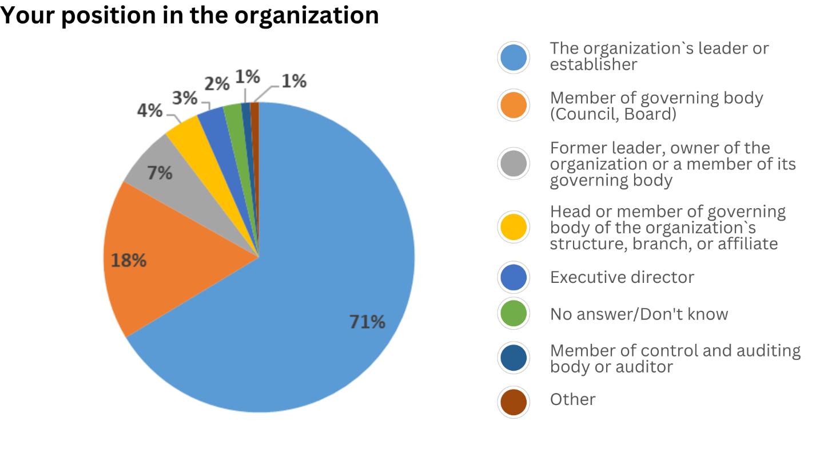
71% of representatives of civil society organizations (CSOs) who responded to this question indicated that they are leaders and/or establishers of the organization; 18% are members of a governing body (Council, Board); 7% are former leaders, owners, or governing body members; 4% are leaders or members of the governing body of the organizational structure, branch or affiliate; 3% are executive directors; 1% are members of the control and auditing body or auditors, and others (staff members in horizontal organizational chart). 2% chose the option ‘No answer/Don`t know’.

1.1. Legal Status of CSOs
49% of CSOs said that they are in the process of liquidation or liquidated in Belarus, 36% said the organization is registered outside of Belarus, 17% said the organization has not been registered in Belarus, 12% said the organization is registered as an NGO in Belarus (a public association, a foundation, an institution, a union, or an association), and 10% - the organization plans to register outside of Belarus.
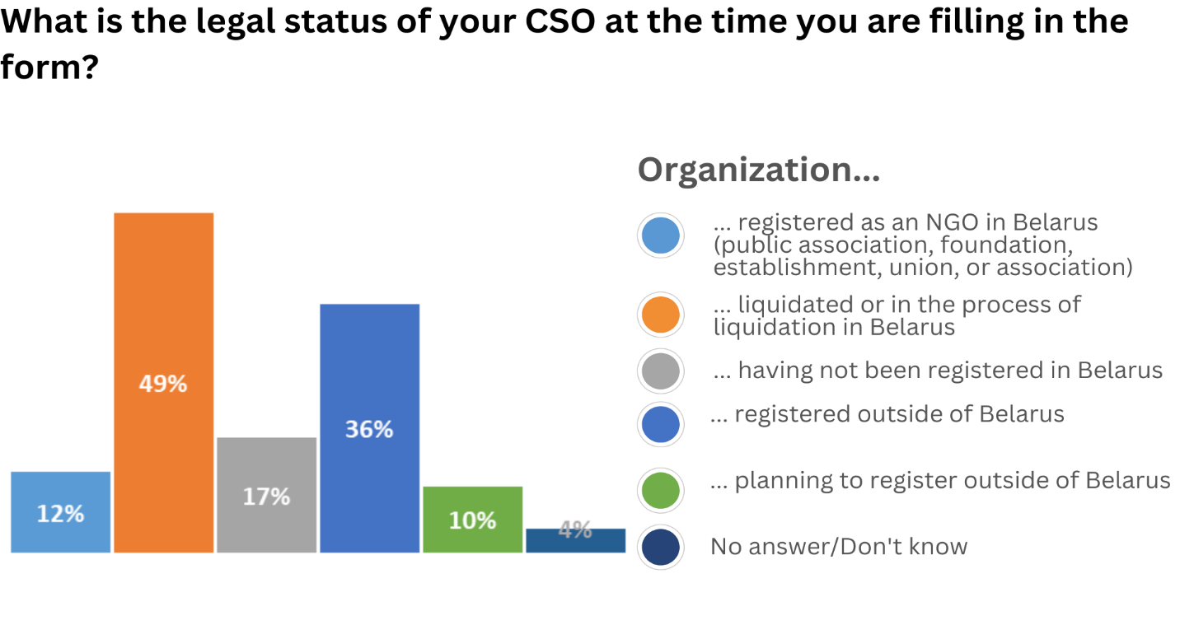56% of CSOs registered outside of Belarus indicated that the organization had been registered abroad after 2020, and 44% were registered before 2020.
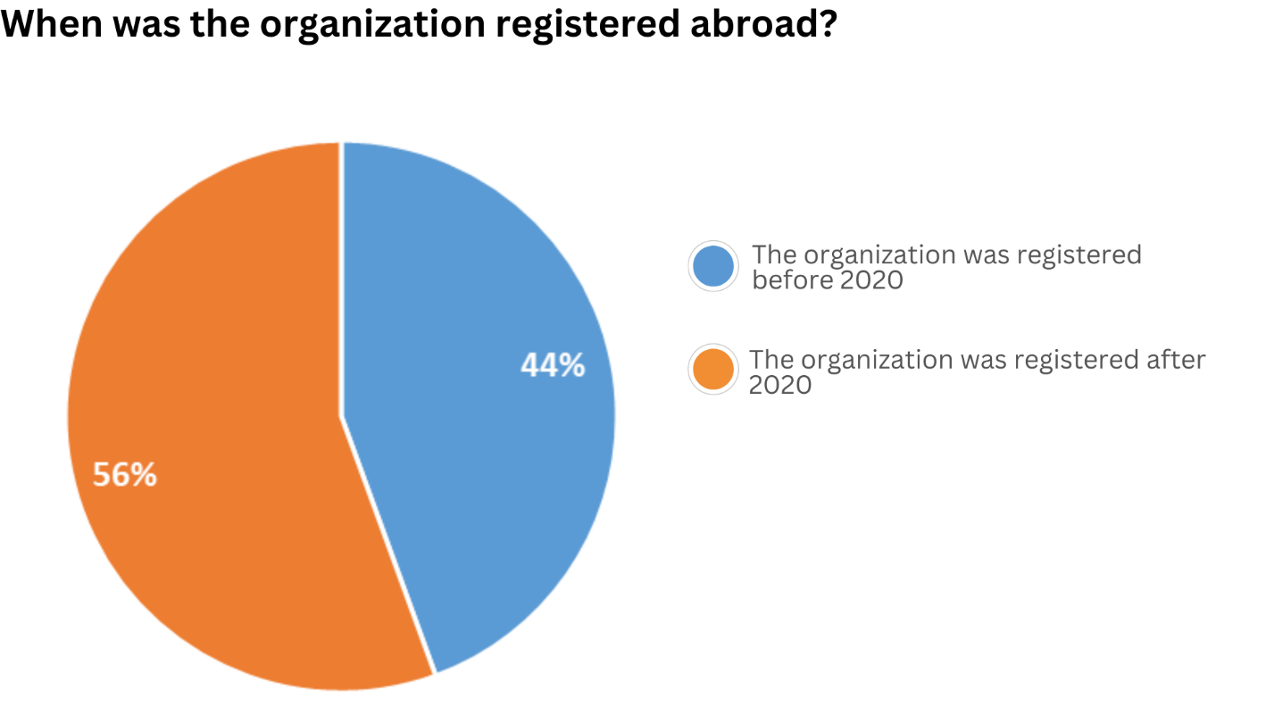

97% of the CSOs with registered status abroad stated that the organization continues carrying out its activities; 3% had adjusted its mission refocusing its activities in the interests of another country (a country of relocation, Ukraine, etc.).
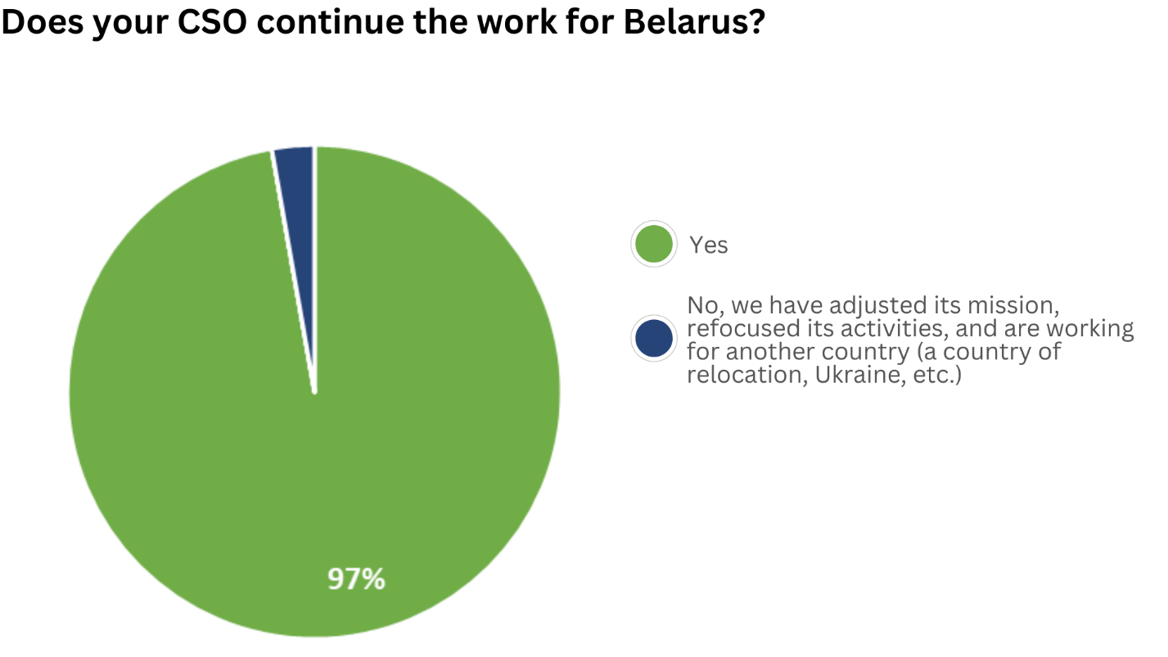
21% of the CSOs surveyed were established before 2000, 20% were before 2015, 13% were after 2020, 12% were before 2010, 11% were before 2020 and the same number were before 1995, 8% were before 2005, and 4% were before 1990.
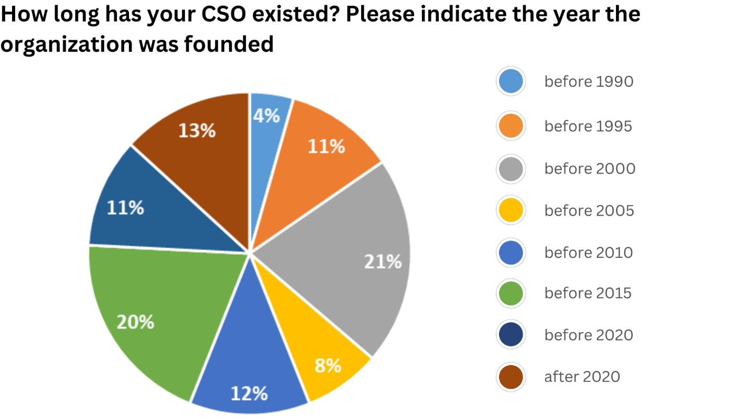
1.2. Areas of Activity and Target Groups of CSOs
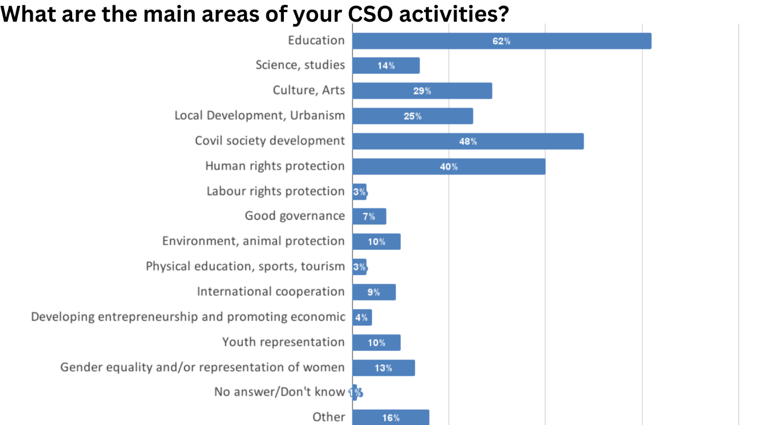

The most common areas of activity amongst the CSO are education (62%), civil society development (48%), human rights protection (40%), culture and arts (29%), and local development and urbanism (25%). 1% found it difficult to answer the question about the main areas of their activity. It can be assumed from other answers that their activities are suspended.
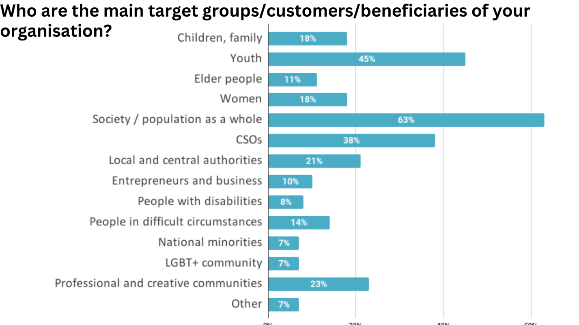
Meanwhile, the main target groups of CSOs participating in the survey are society/the general public (63%), youth (45%), civil society organizations (38%), professional and creative communities (23%), and local and central government (21%). The 'Other' option (7%) included human rights defenders, political prisoners, teachers, cultural figures, historians, and students.
1.3. Leadership of CSOs
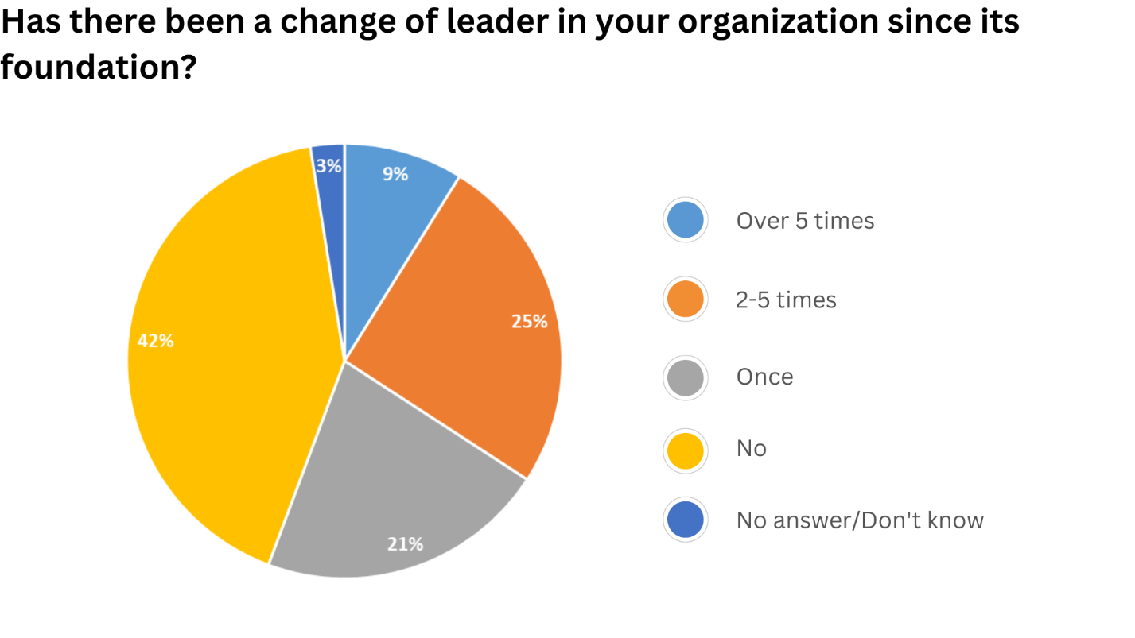
42% of CSOs indicated that the organization`s leader has never changed since its foundation, 25% indicated 2-5 times, 21% indicated once, 9% indicated more than 5 times and 3% did not answer this question.
2. Cooperation and Interaction of Belarusian CSOs with Each Other and Other Actors

2.1. CSO Participation in Coalitions and Umbrella Structures

The majority of Belarusian CSOs work inter alia in the framework of coalition activity. 43% of the surveyed CSOs are members of Belarusian and international coalitions and umbrella structures, 23 % are not members of any coalition structures, 21 % are only of Belarusian ones, 5 % are only of international ones, and 7% failed to answer this question.
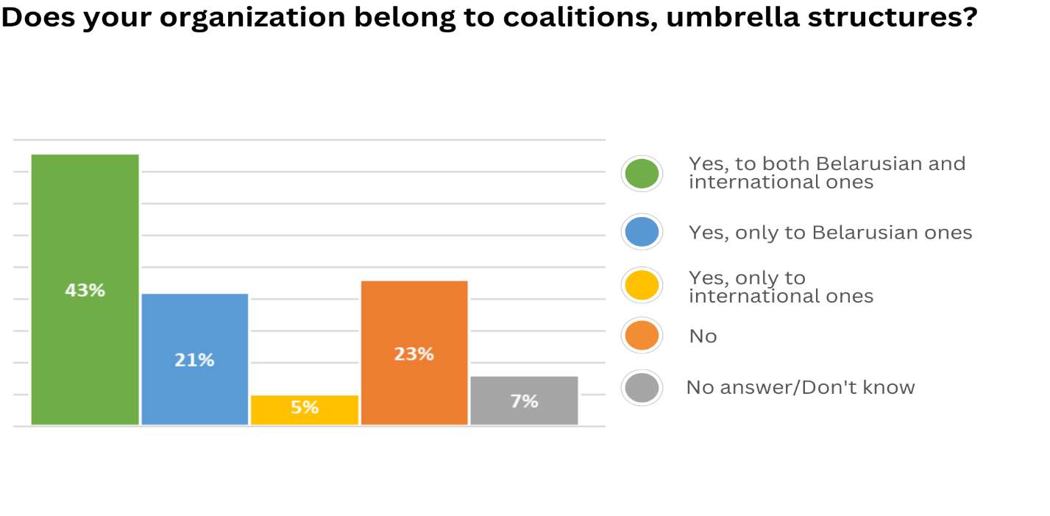
2.2. CSO Interaction with Other Belarusian and International Actors
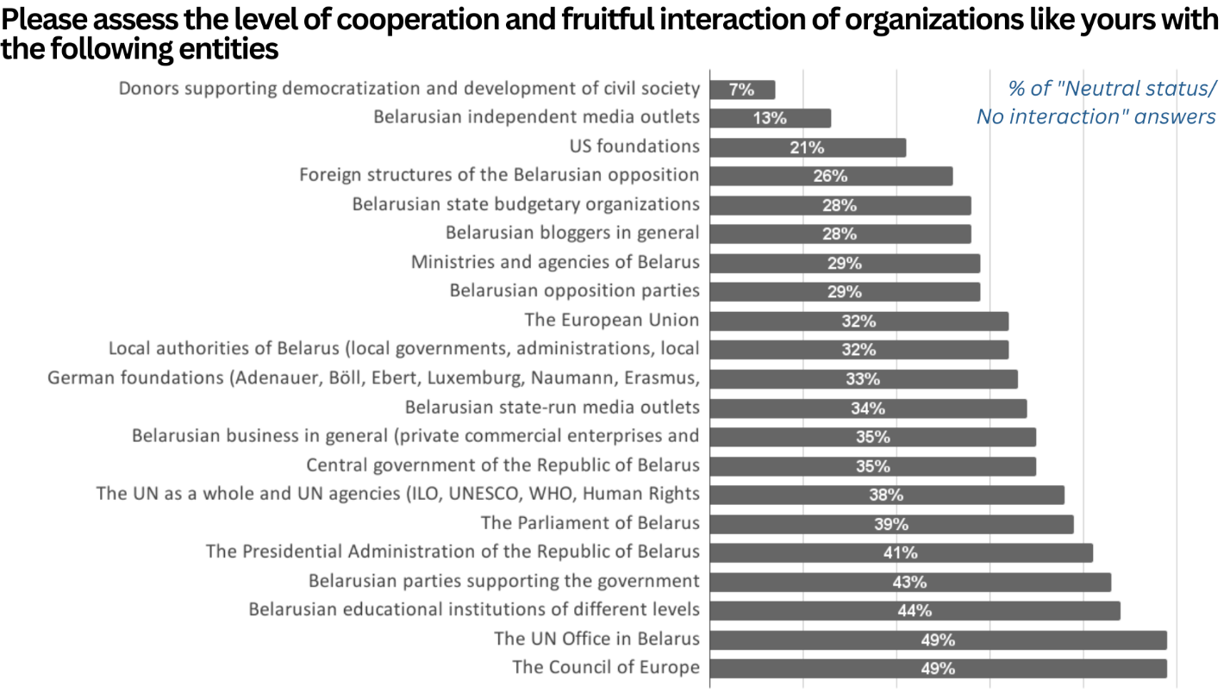

The CSOs have different levels of interaction with various actors, depending on their role in the political life of the country, the way of presenting information, its dependence on the state ideology, and financial relations with CSOs. The CSOs participating in the survey were asked to assess the level of their cooperation and interaction with national and local authorities, state-run and independent media outlets, donors, political parties and opposition structures, international institutions, and other entities. The rating was carried out on a scale of 1 to 10, where 1 means "poor or negative interaction" and 10 means "full cooperation and mutual understanding in joint activities". Those participating in the survey were also offered an additional response option of "Neutral status/No interaction".
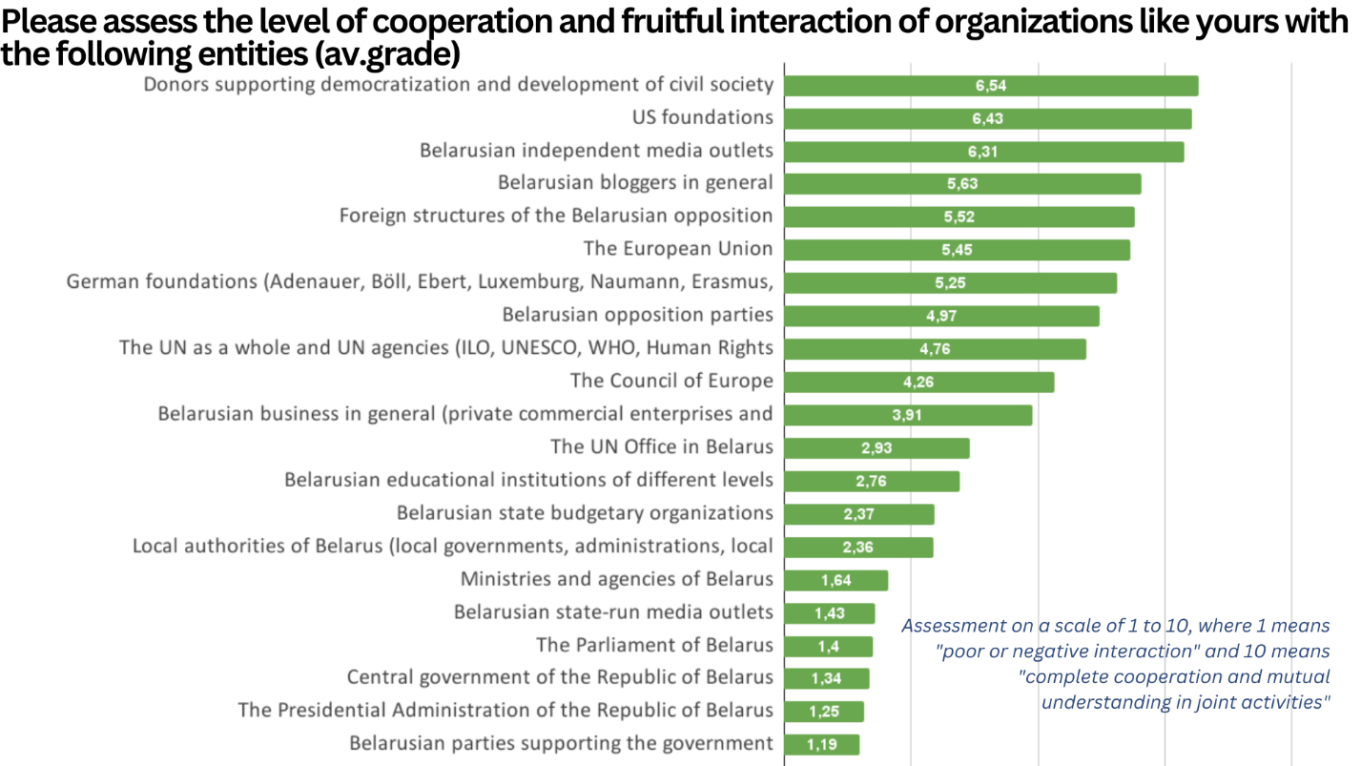
Interacting Entity | 1. Poor or negative interaction | 2 | 3 | 4 | 5 | 6 | 7 | 8 | 9 | 10. Complete cooperation | Lack of interaction
The central authorities of Belarus | 50 % | 11 % | 1 % | 1 % | 1 % | 0 % | 0 % | 0 % | 0 % | 0 % | 35 %
The Presidential Administration of Belarus | 50 % | 6 % | 0 % | 1 % | 1 % | 0 % | 0 % | 0 % | 0 % | 0 % | 41 %
The Parliament of Belarus | 46 % | 9 % | 2 % | 4 % | 0 % | 0 % | 0 % | 0 % | 0 % | 0 % | 39 %
Ministries and agencies of Belarus | 48 % | 10 % | 7 % | 4 % | 2 % | 0 % | 0 % | 0 % | 0 % | 0 % | 29 %
Local authorities of Belarus (local governments, administrations, local councils) | 35 % | 4 % | 15 % | 2 % | 9 % | 4 % | 0 % | 0 % | 0 % | 0 % | 32 %
Belarusian opposition parties | 7 % | 6 % | 11 % | 4 % | 13 % | 12 % | 5 % | 5 % | 2 % | 5 % | 29 %
Belarusian parties supporting the government | 52 % | 1 % | 2 % | 0 % | 1 % | 0 % | 0 % | 0 % | 0 % | 0 % | 43 %
Foreign structures of the Belarusian opposition | 5 % | 4 % | 6  % | 10 % | 12% | 10 % | 15 % | 6 % | 2 % | 5 % | 26 %
Donors supporting democratization and development of civil society | 2 % | 2 % | 6 % | 6 % | 10 % | 12 % | 20 % | 15 % | 10 % | 9 % | 7 %
The UN as a whole and UN agencies (ILO, UNESCO, WHO, Human Rights Council) | 7 % | 4 % | 12 % | 9 % | 5 % | 6 % | 10 % | 7 % | 1 % | 1 % | 38 %
The UN Office in Belarus | 20 % | 9 % | 9 % | 1 % | 5 % | 2 % | 5 % | 1 % | 0 % | 0 % | 49 %
The Council of Europe | 10 % | 5 % | 10 % | 4 % | 6 % | 5 % | 5 % | 5 % | 2 % | 0 % | 49 %
The European Union | 6 % | 4 % | 9 % | 2 % | 16% | 4 % | 11 % | 10 % | 6 % | 1 % | 32 %
German foundations (Adenauer, Böll, Ebert, Luxemburg, Naumann, Erasmus, Seidel, etc.) | 11 % | 4 % | 5 % | 6 % | 7 % | 5 % | 13 % | 10% | 4 % | 2 % | 33 %
US foundations | 6 % | 2 % | 6 % | 2 % | 4 % | 12 % | 12% | 13 % | 6 % | 13 % | 21 %
Belarusian state-run media outlets | 50 % | 7 % | 5 % | 4 % | 0 % | 0 % | 0 % | 0 % | 0 % | 0 % | 34 %
Belarusian independent media outlets | 4 % | 5 % | 9 % | 7 % | 9 % | 2 % | 12 % | 24% | 6 % | 9 % | 13 %
Belarusian bloggers in general | 5 % | 2% | 9 % | 5 % | 11 % | 10 % | 12 % | 15 % | 2 % | 1 % | 28 %
Belarusian business in general (private commercial enterprises and entrepreneurs) | 9 % | 13 % | 11% | 5 % | 10 % | 6 % | 9 % | 2 % | 0 % | 0 % | 35 %
Belarusian state budgetary organizations | 30 % | 9 % | 5 % | 2 % | 4 % | 1 % | 4 % | 1 % | 0 % | 0 % | 44 %
Belarusian educational institutions of different levels | 27 % | 2 % | 6 % | 9 % | 5 % | 5 % | 2 % | 0 % | 0 % | 0 % | 44 %

3. Specifics of CSOs in the Conditions of Relocation

3.1. General Situation with the CSO Relocation
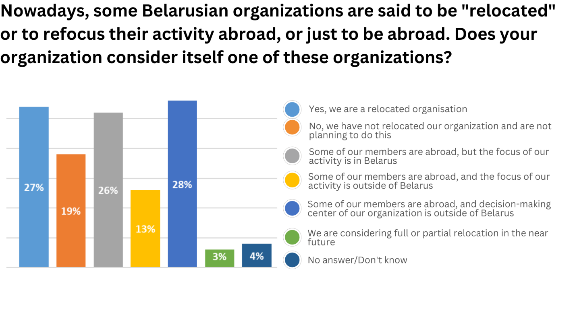
Asked whether a CSO consider itself a "relocated" organization, 27% of the CSOs responded that they are a relocated organization; 28% said that some of their members and a decision-making center are outside Belarus; 26% said that some of their members are abroad, but the focus of their activity is in Belarus; 19% said that they are not a relocated organization and have no such plans; 13% said that some their members and the focus of their activity are abroad; 3% consider full or partial relocation in the near future, and 4% had no answer to the question.

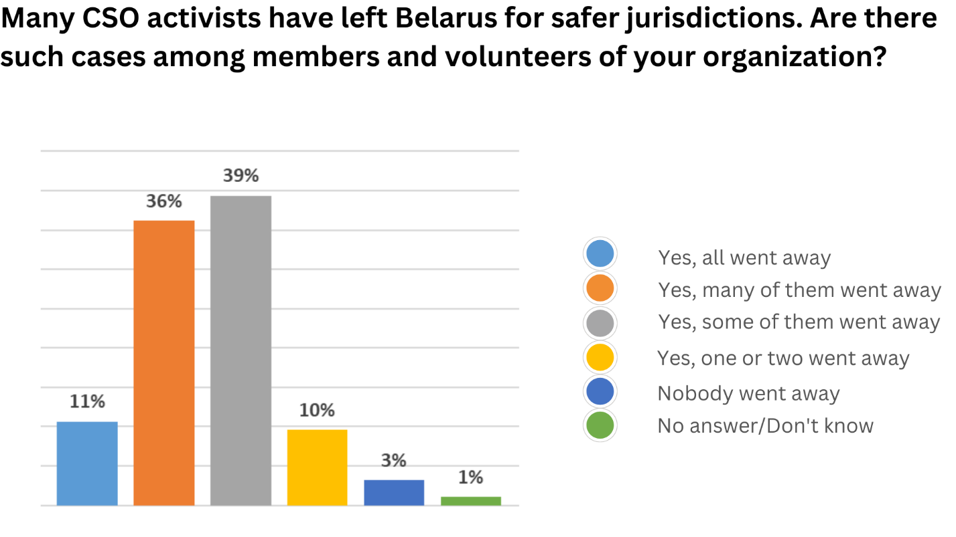

36% of the CSOs responded that a lot of their members left Belarus for safer jurisdictions, 39% responded that some ones fled Belarus, 11% responded that all the staff left, 10% responded that one or two people left, 3% responded that no one left, and another 1% had no answer to this question.

56% of the CSOs believe the departure of the organization's members abroad is mostly temporary but long-term, 32% think it is difficult to say in relation to all their members whether the departure abroad is permanent or temporary, 3% believe that the departure of their members is permanent, 3% believe that the departure is temporary and short-term, and for 6% did not answer the question.
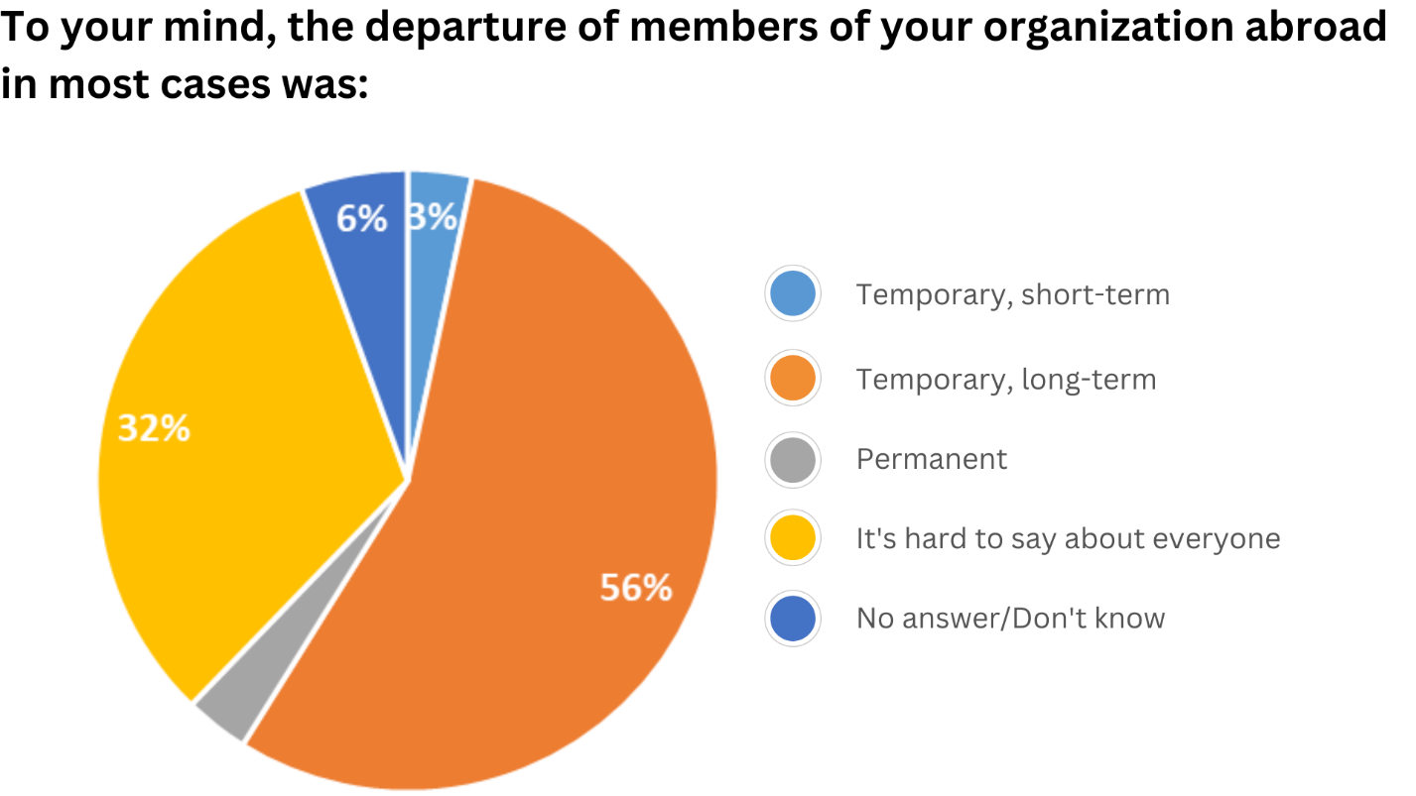
3.2. Interaction of Relocated CSOs with the Country of Residence`s Entities
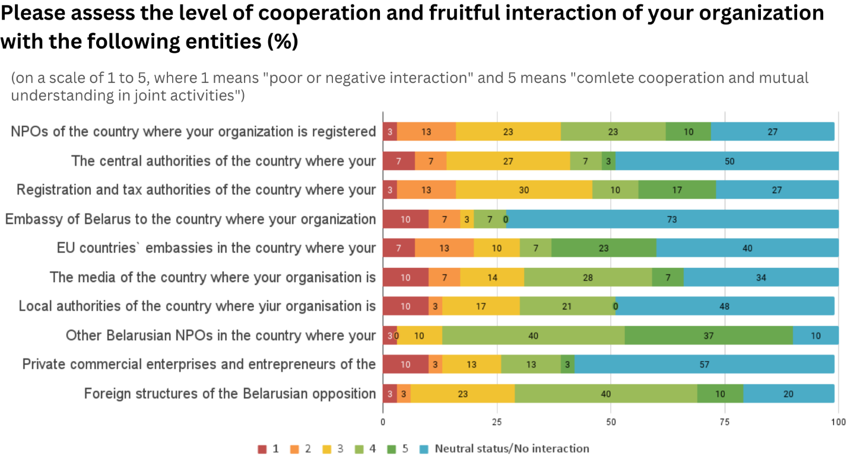
The CSOs registered outside of Belarus, in addition to assessing the level of interaction with Belarusian actors, were asked to assess their level of interaction with various actors of the country of registration. The level of interaction was rated on a scale from 1 to 5, where 1 means "poor or negative interaction" and 5 means "complete cooperation and mutual understanding in joint activities"; additionally, one could also choose ‘Neutral status/No interaction’. The following results regarding the level of interaction were obtained:
Interacting entities of the country where an organization is registered | 1. Poor or negative | 2 | 3 | 4 | 5 | Neutral status/No interaction
NPOs | 3% | 13% | 23% | 23% | 10 % | 27%
Central authorities | 7% | 7% | 27% | 7% | 3 % | 50%
Registration and tax authorities | 3% | 13% | 30% | 10% | 17% | 27%
Embassy of Belarus | 10% | 7% | 3% | 7% | 0% | 73%
EU countries` embassies | 7% | 13% | 10% | 7% | 23% | 40%
The media | 10% | 7% | 14% | 28% | 7% | 34%
Local authorities | 10% | 3% | 17% | 21% | 0% | 48%
Other Belarusian CSOs | 3% | 0% | 10% | 40% | 37% | 10%
Private commercial enterprises and entrepreneurs | 10 % | 3 % | 13 % | 13 % | 3 % | 57 %
Foreign structures of the Belarusian opposition | 3 % | 3 % | 23 % | 40 % | 10 % | 20 %

4. Challenges and needs of CSOs

4.1. Forms of the state pressure on Belarusian CSOs
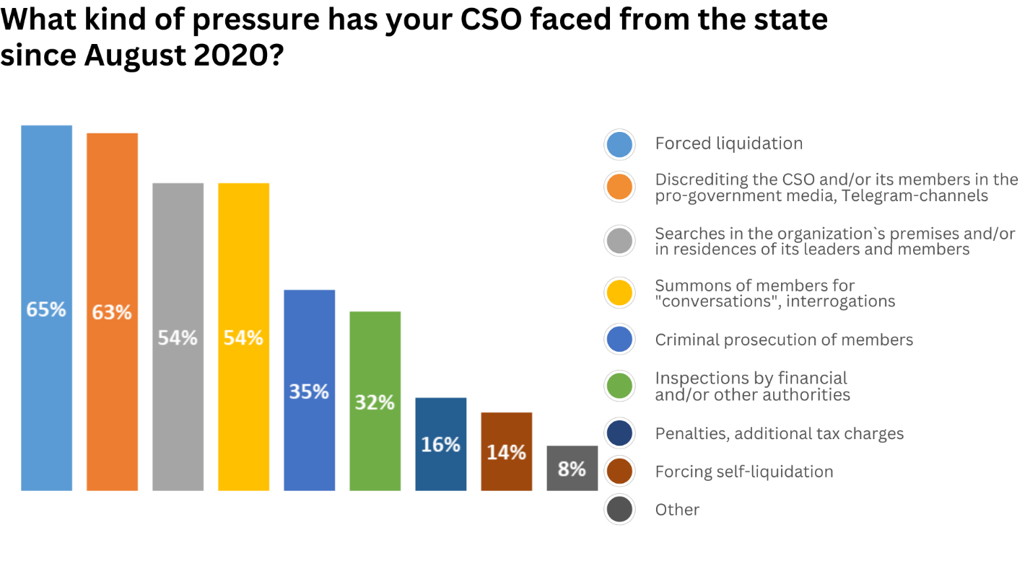
Since August 2020, Belarusian CSOs have been facing constant pressure from government agencies. At the same time, the intensity of the pressure has been increasing. The CSOs noted that they most often face the following forms of the state pressure: forced liquidation (65%), discrediting CSOs and/or CSO members in the pro-government media, Telegram-channels (63%), searches in the organization`s premises and/or in residences of its leaders and members (54%), summons of members for "conversations" and interrogations (54%), persecution of members (35%), inspections by financial and/or other authorities (32%), penalties and additional tax charges (16%), and forcing self-liquidation (14%). 8% of the CSOs also faced other forms, such as forcing relocation, inability to carry out financial activities, forcing cooperation of special services, and pressure on their members` relatives in Belarus.
4.2. Factors Affecting CSO Activities at Present
The factors that the CSOs listed as those having the greatest impact on their development at present can be conveniently classified into several areas:
General situation in Belarus | Uncertainty  Political situation in Belarus, with unpredictable developing  Repression, human rights situation  Out migration of specialists from Belarus  Security issues  Presence of political prisoners  Level of solidarity in the society  Open/closed borders
Situation in Belarus relating to CSOs | Deeming an extremist formation (followed by difficulties with attracting new members, target groups, participants of events, cooperation with other CSOs, and limited or non-public events)  Intimidation, arrests of activists and leadership, reprisals against them  Safety of leadership, staff, members, and volunteers  Ban on CSO activities in Belarus  Uncertainty of the CSO`s legal status in Belarus (how long it will last)  Legislative changes  Inability to cooperate with many state institutions
Situation outside of Belarus | Uncertainty  Geopolitical processes  Russia's war against Ukraine, with its consequences  Situation in Georgia (unpredictability, political situation, security issues, financial situation)  Attention to Belarus internationally
Challenges arising from CSOs relocation | The very fact of relocation  Monopolization of funding by certain actors  Necessity to organize a work abroad after relocation  Necessity to solve most important common issues of staff members: seeking accommodation, sending children to school  Lack of residence permits for staff members  Obtaining visas for staff members  Difficulties with access to target groups in Belarus  Difficult communication between CSOs being in different countries  Lack of opportunity to open an account for an organization in Georgia
Specific factors affecting the activities of CSOs regardless of location | Lack of funding sufficient for work  Short-term projects, "small" grants  Financial flexibility of donors, reporting security issues  Lack of funds for institutional support of CSOs and purchase of equipment  Donor priorities that not being coordinated with CSOs  Changes in the needs and demands of target groups  Refocusing CSO activities and donor support  Team resilience, including psychological, mental and physical well-being, as well motivation  Lack of qualified human resources, volunteer turnover, and burnout  Obtaining visas for CSO members, including those in Belarus  Quick possibility to relocate those members who staying in Belarus, in case of such a need  Organization of activity both outside and inside Belarus  Absence of general vision and strategy for the organization development  Lack of understanding of the role the organization's specific activities play in the development of civil society and introduction of democratic values by international actors

4.3. Main Obstacles to the CSO Activities
The main obstacles to the activities of the Belarusian CSOs are harassment, reprisals and new restrictions for their activities in Belarus, it was noted by 80% of the CSOs. 63% of the CSOs featured the relocation of members and the need to organize the CSO operating abroad as an obstacle to their activities. The following main obstacles were mentioned: liquidation and prohibition of CSOs activity (61%); loss of the communication with target groups (59%); psychological, medical problems and burn-out of staff and volunteers (56%); dependence on foreign financing (53%); blocked informational resources of the organization within Belarus (37%); reduced access to funding (34%); shortage of qualified staff (workers, volunteers) (29%); low communication between Belarusian CSOs (27%); lack of communication with the Belarusian authorities (24%); lack of communication with donors (16%); low access to legal aid (9%); and lack of access to Belarus` government bodies websites (5%).
4.4. Main Challenges for CSOs of Belarus
The CSOs participating in the survey were asked to answer the question about the three main challenges faced by Belarusian CSOs. In the analysis of the results to the question, the challenges mentioned most often are presented.
Safety | Ensuring the safety of activists in Belarus  Increasing repression  Pressure on the organization, forced closure of the organization in Belarus  Ensuring physical and psychological safety, including during relocation  Organizing safe work with target groups in Belarus  Safe transfer of funds within the country, organization of financial activities  Excessive (insecure) reporting requirements from donors  Cybersecurity
Financial activities | Lack/reduced access to funding (foreign and domestic), reduced resource support  Unstable support from international organizations and donors, lack of stable access to financing and long-term projects (3-5 years)  Lack of skills in working with donors (inability to write proposals, lack of information on calls for application and donors)  Forced abandonment of "small" grants due to increased financial costs caused by relocation  Low earnings in the conditions of relocation  Greater dependence on donor policies (security issues, increase or decrease in resource support)
Involuntary relocation | Refocused activities due to departure from Belarus  Registration/legalization in countries of relocation, difficulties in opening or reopening CSOs in new countries  Reshaping communications in connection with relocation (communications within the organization, communications Belarus - relocants)  Changed work conditions, work under new legislation, lack of awareness of the countries of relocation`s law  Formation of organizational and administrative work in the country of relocation (financial costs, time, necessity to find specialists within the country of relocation, lack of recommendations)  Loss of the gained capabilities (human, technical, and material) and relations, the need to start practically afresh  No or negligible support mechanisms at the state and municipal levels for the CSOs and their members relocated for political reasons in the countries of relocation  Sharp increase in organizational costs due to relocation
Human Resources | Burnout, depression, psychological instability, health problems of the organization's members and activists  Searching for new staff members  Need to establish work with members of different countries and often with new members  Out migration of specialists from Belarus  Leaving the civil sector and changing activists' activity profile due to relocation  Lack of motivation, lack of success
Uncertainty | Unclear outlook for the near future  Lack of forecasting in an unstable environment  Lack of understanding of the state of the CSO in general
Organization of activities | Assessment of the effectiveness of activities in the current conditions and its planning  Inability to work openly and to organize activity in Belarus  Minimal opportunity to inpact the situation in Belarus (working only on informing, education, etc. in the long term)  Visa restrictions  Different needs of target groups inside and outside Belarus  Criminal prosecution for acting on behalf of an unregistered/liquidated organization  Need to rebuild organizational structure  Lack of access to information sources and statistics
Interaction with target groups and other actors | Changed target groups  Loss of connection with target groups  Relocation of the target groups of projects  Disruption of existing relationships with partners at various levels  Lack of understanding of the need to review and to formulate long-term strategies by CSOs in general and by international actors  No or complicated communication and collaboration with other CSOs, lack of information on their activities due to forced non-public working  Gap between organizations left Belarus and those staying there, as well between their strategies and terms of functioning  Fear among experts, the media, and target groups to cooperate directly with CSOs under pressure  Necessity to prove to donors the importance of concrete work with a target group, with its needs  Non-participation in the development of donor policies
Changes in policies and practices of other actors | Decreased attention to the Belarus theme in connection with the war in Ukraine  Turning the spotlight on Ukraine  Changes in donor practices and decrease in funding  Danger of integration into Russian Federation
4.5. Basic Needs of CSOs in Belarus
Material resources, including equipment and funding, were noted as the main need by 75% of the CSOs. There are visa support of an organization's members, including those in Belarus (63%), ensuring physical safety of the members (52%), organizational development and strategic planning (48%), advanced training for members: seminars, courses, and internships (47%), and access to the dissemination of information to the audience in Belarus (45%) among the basic needs. 7% of the CSOs referred to some other needs: support of long-term institutional projects, help in embracing modern digital technologies, support of offline meetings of the organization`s members of different countries, and financial support of volunteer team activity.
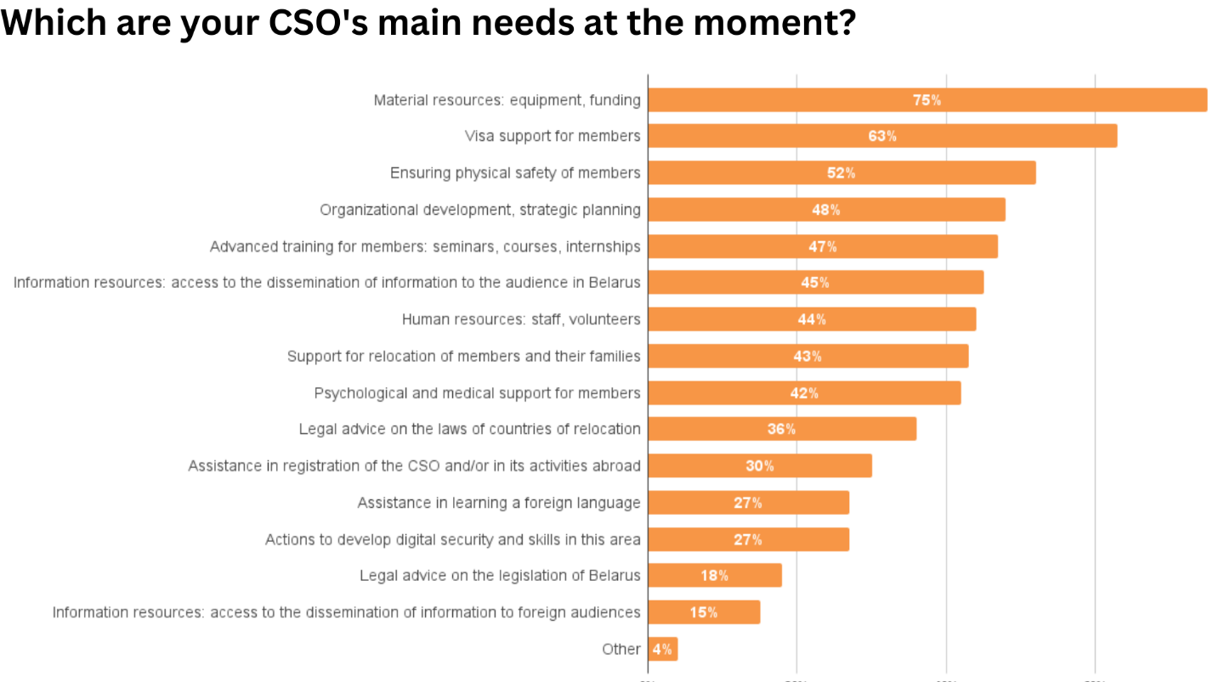
5. Prospects and Planning of CSO Activities

5.1. Time Frame for CSO Planning
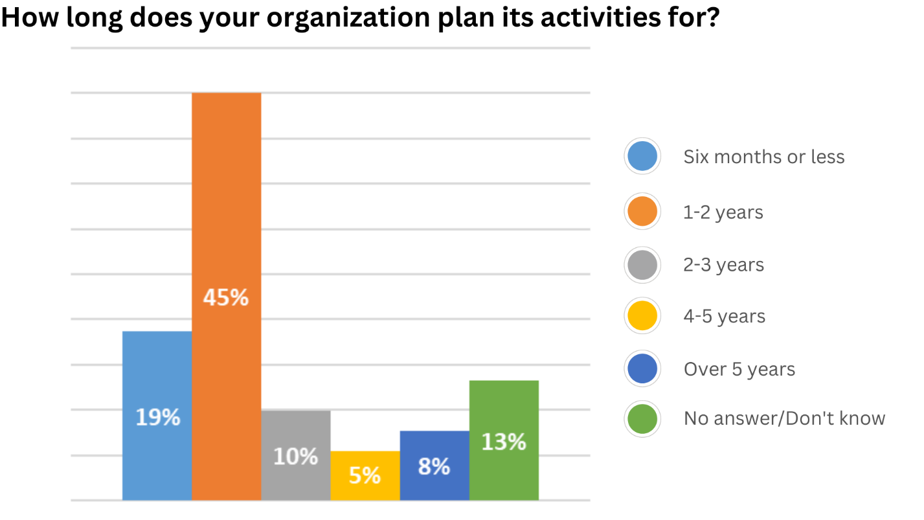

The relocation of many CSOs to safer jurisdictions during the "major wave" and long staying there made it possible to plan their activities for a longer period than in 2021. At the same time, planning time frame for most CSOs is short: 45 % of the CSOs plan their activities for 1-2 years, 19 % plan for six months or less, 10 % plan for 2-3 years, 5 % plan for 4-5 years, and 8 % do it for over 5 years; 13 % of CSOs do not have an answer to this question.
5.2. Approaches to Planning CSO Projects/Activities
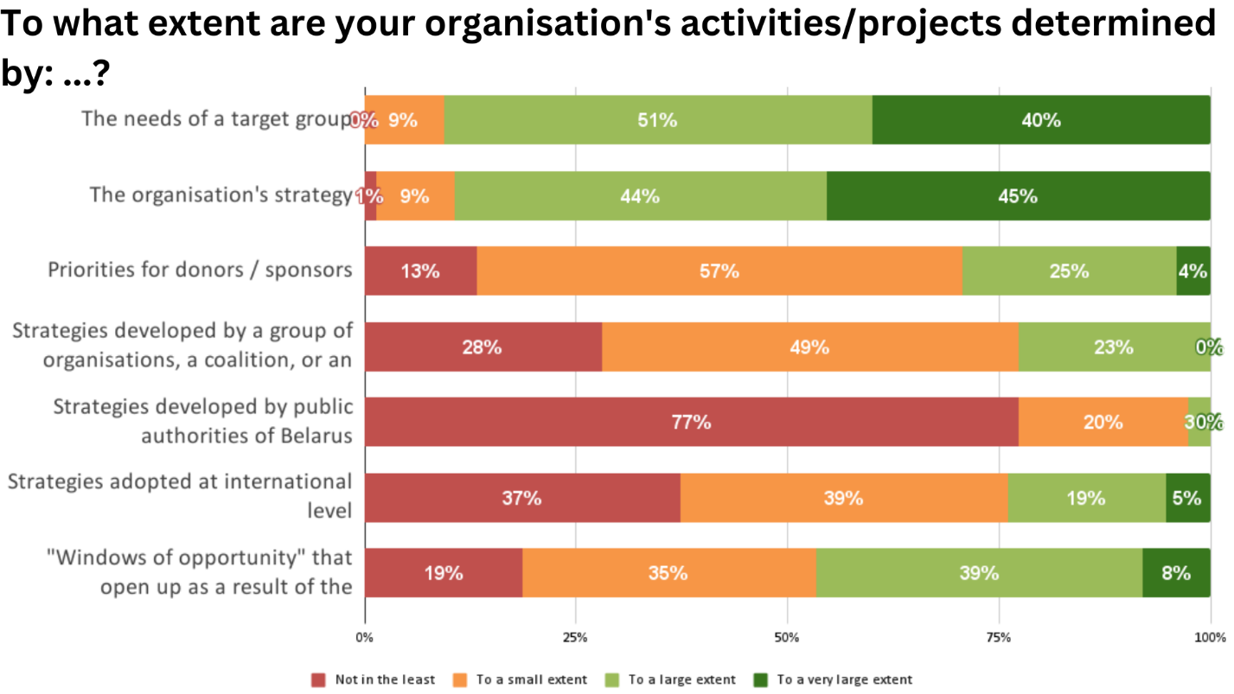
The CSOs were asked to ascertain how they plan their projects and/or activities according to these criteria:
Criterium | Not in the least | To a small extent | To a large extent | To a very large extent
Needs of a target group | 0 % | 9 % | 51 % | 40 %
The organization's strategy | 1 % | 9 % | 44 % | 45 %
Priorities for donors/sponsors | 13 % | 57 % | 25 % | 4 %
Strategies developed by a group of organizations, a coalition, or an umbrella structure | 28 % | 49 % | 23 % | 0 %
Strategies developed by state bodies of Belarus | 77 % | 20 % | 3 % | 0 %
Strategies adopted at international level | 37 % | 39 % | 19 % | 5 %
"Windows of opportunity" that open up as a result of the government or other stakeholder policies | 19 % | 25 % | 39 % | 8 %
5.3. Prospects for CSO Activities for the Next Two or Three Years
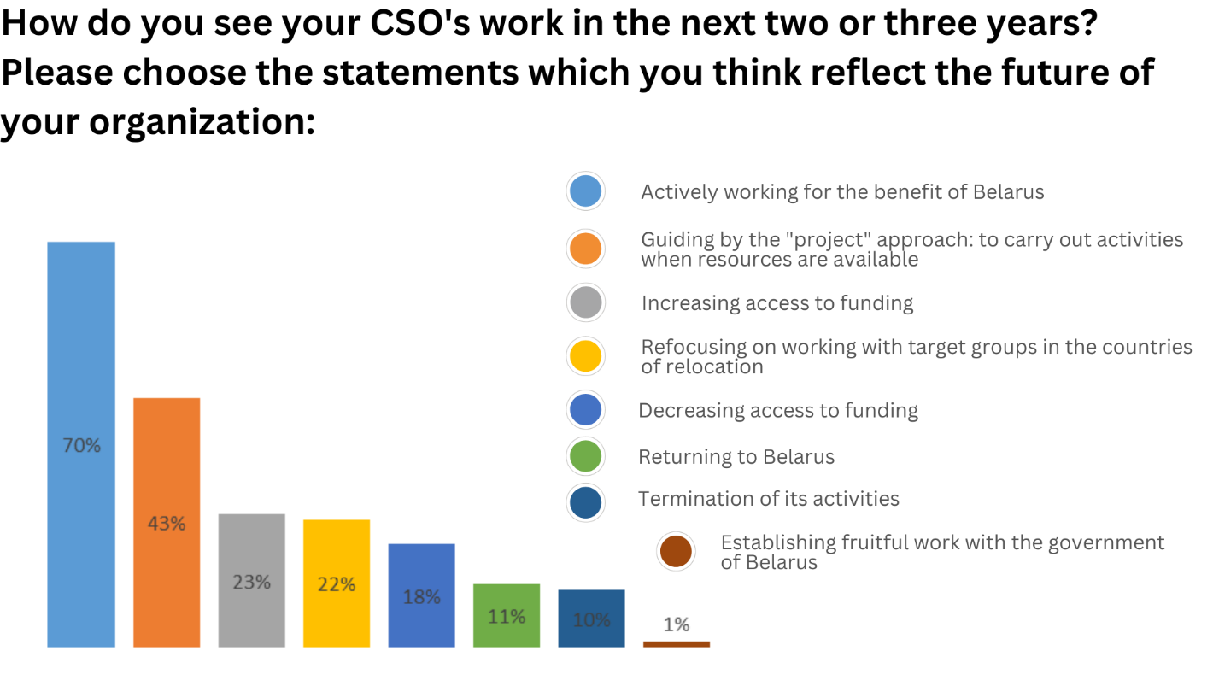
70% of the CSOs state that they will actively continue their activities for the benefit of Belarus, 43% will follow a "project" approach: to carry out activities if resources are available, 22% will refocus on working with target groups of the countries of relocation, and 10% will stop their activities. At the same time, 23% of the CSOs are confident that their access to funding will increase in the next 2-3 years, while 18% of ones believe that their access to funding will decrease. 11% of the CSOs held that they will return to Belarus in the next 2-3 years. Only 1% of the CSOs say that they will arrange effective work with the Belarusian government in the next 2-3 years.
5.4. Key Factors Affecting CSOs in the Next Year
The factors that, according to CSOs, will have the greatest impact on their development in the next year can be classified into several areas:
General situation in Belarus | Uncertainty of the situation  Participation/non-participation of the Belarusian state in the war on the side of Russia  Level of reprisals  Transformation of the political situation in Belarus  Digital ‘Iron Curtain’ separating Belarusians from the rest of the world  Security  Presence of political prisoners  Open/closed borders  Level of solidarization in the society
Situation in Belarus with respect to CSOs | Recognising CSOs as terrorist or extremist entities  Repression of CSOs and their activists, security  Possibility to legalize their activities  Lack of safe forms of civic participation within the country  Closing up CSOs  Depriving CSOs a legal status  Inability to cooperate with state authorities
Situation outside of Belarus | Geopolitical processes  Russia's war with Ukraine  Safe situation in Georgia  Security in the region  Changing policies and priorities of international organizations  Strengthening of Russian information influence
Challenges arising from CSO relocation | The fact of relocation  Attitude to Belarusians by the authorities and society in the country of relocation  Changed legislation in Poland where the organization is registered in relation to Belarus and Belarusians  Possibility of getting involved in programs, including regional and international ones, aimed at target groups in Belarus  Opportunity to legalize activities  Further restrictions on work with target groups inside the country
Certain factors affecting the activities of CSOs regardless of location | Financial (un)sustainability, lack of donor funding, seeking funds to work and to implement programs and projects  Monopolization of funding by some actors  Burnout, frustration/stress/psychological problems of the team, physical health of team members  Activity of programs and funds in relation to Belarus, decrease in financing and attention to the Belarusian agenda of international partners  Successful retention of old staff, difficulties in recruitment of new team members  Change of needs and requests of target groups  Necessity of strategic planning according to the changing situation  Need to monetize products and increase expertise  Search of organizations and initiatives to collaborate with, collaboration with umbrella structures  Being of members and personnel in various countries

5.5. Key Factors Affecting CSOs in the Next Three Years
The factors that the CSOs believe to have the greatest impact on their developing in the next three years can also be conveniently classified into several areas:
General situation in Belarus | Possibility/impossibility to return to Belarus  Extension/decline of the Belarusian regime  Potential complete loss of the independence and sovereignty by Belarus  Presence of political prisoners  Level of making common cause in the society  Closed/open borders  Formation of New Belarus, creation of the conditions and opportunities for CSOs to work there
Situation outside of Belarus | Results of the war in Ukraine  Changes in the world, the situation in the region, including migration  Aggression on the part of Russia against European states, including Belarus  Lack of interest in Belarus at the international level  Sectional policy towards Belarus
Challenges arising from CSO relocation | Safe stay in the country of relocation  Lack of contacts between the leadership and activists abroad and those in Belarus, as well target groups in the country
Certain factors affecting the activities of CSOs regardless of location | Financial (un)sustainability, lack of donor funding, seeking funds to implement programs and projects in this prospect, lack of long-term projects  Donor policies towards CSOs  Monopolization of funding by some actors  Motivated people who will stay with CSOs  Successful retention of valuable and competent staff  Shared vision for the organization development  (Un)sustainability of the team, burnout, lack of a healthy team atmosphere  (Un)sustainability of the organization in difficult conditions  Lack of opportunities for professional growth in CSOs  Increasing the organizational capacity  Acquiring new knowledge and skills by team members, taking into account the changed situation and their roles in the team  Construction of the best strategy for achieving the organization's goals  New trends in civic and political participation  New demands and needs of target groups  Opportunity ‘to approach the market’ of CSOs in other EaP countries  Minimal impact on the target groups and the overall situation in the country  Dependence on political process (when if there is no change in this perspective, the CSO will cease its activities)  Lack of understanding of the role the organization's specific activities play in the development of civil society and introduction of democratic values by international actors
5.6. The Level of CSO Interaction with Belarusian and International Actors in the Next Three Years
The CSOs participating in the survey were asked to outline their expectations for cooperation and interaction with various actors - national and local authorities, state-run and independent media outlets, donors, political parties and opposition structures, international institutions, and other actors - in the next three years.
Interacting entity | Relationship will deteriorate | Relationship will remain the same | Relationship will improve
Central authorities of Belarus | 43 % | 53 % | 5 %
Local authorities of Belarus (local governments, administrations, local councils) | 38 % | 50 % | 13 %
Belarusian opposition | 10 % | 66 % | 24 %
Donors supporting democratization and development of civil society | 5 % | 56 % | 39 %
The UN as a whole and UN agencies (ILO, UNESCO, WHO, Human Rights Council) | 8 % | 79 % | 14 %
The UN Office in Belarus | 13 % | 81 % | 6 %
The Council of Europe | 42 % | 70 % | 26 %
The European Union | 9 % | 58 % | 34 %
German foundations (Adenauer, Böll, Ebert, Luxemburg, Naumann, Erasmus, Seidel, etc.) | 10 % | 51 % | 39 %
US foundations | 9 % | 50 % | 41 %
Belarusian business in general (private commercial enterprises and entrepreneurs) | 13 % | 69 % | 19 %
Belarusian state budgetary organizations | 26 % | 71 % | 3 %
Belarusian educational institutions of different levels | 31 % | 59 % | 10 %

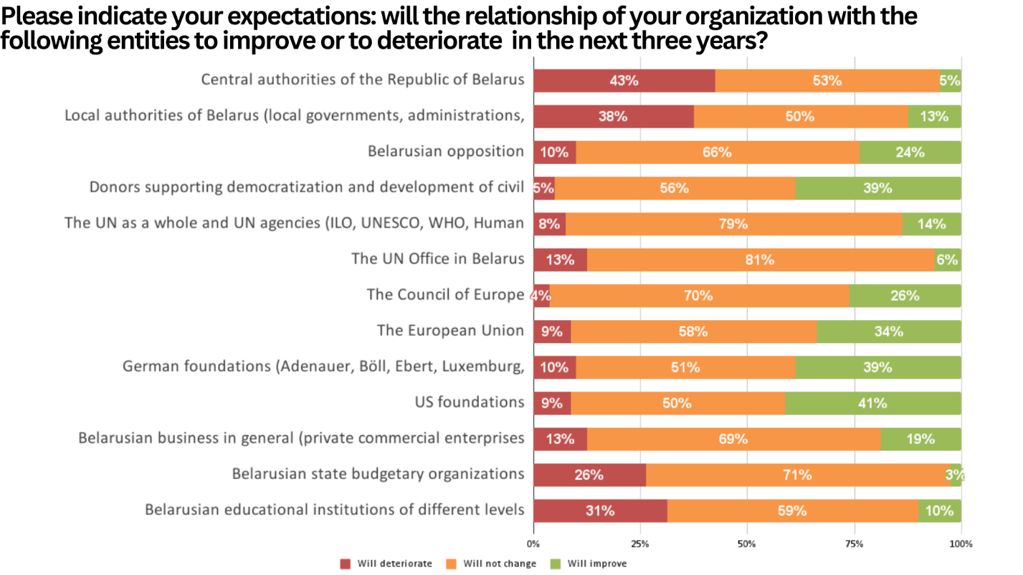

5.7. Human Resources in CSOs in the Next Three Years
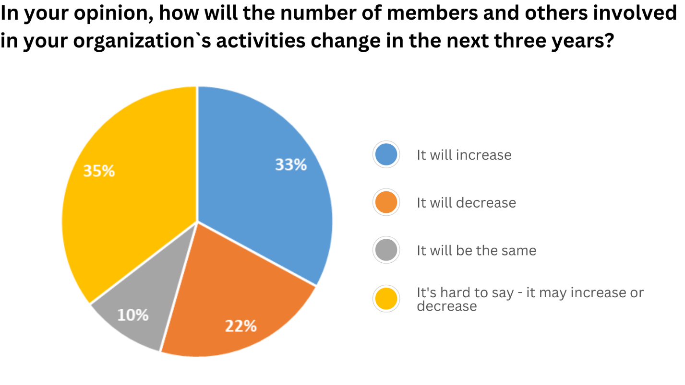
33% of the CSOs believe that, in the next three years, the number of members and others involved in their activities will increase, 35% choose the answer "It's hard to say - it may increase or decrease", 22% believe that the number of members and others involved in their activities will decrease, and only 10% believe that the number of members and others involved in their activities will remain the same.
6. Financial Activities of CSOs

6.1. Fundraising Methods
48% of the CSOs indicate that their fundraising methods have not changed over the past two years, 32% indicate that they have changed their fundraising methods over the past two years, and another 20% of the CSOs have no answer to this question.
The situation varies among the CSOs with regard to changes in their fundraising methods: some CSOs say there is an increase in funding, including in connection with the relocation to safer jurisdictions; some CSOs, primarily those who participate in international technical assistance programs not engaging in independent fundraising, receive foreign grant aid with registration in the Department for Humanitarian Activities and stay in Belarus, emphasize that their funding has decreased. A number of the CSOs indicate the impossibility to obtain funds from foreign sources within the country legally and to participate in the international technical assistance projects; as a result, some of them completely reject of foreign funding. It is also pointed out that domestic funding has decreased. The CSOs use, as new instruments for raising funds, international crowdfunding platforms, Patreon, obtaining scholarships, and contracting on behalf of members of the organization to spend funds more flexibly and participate in projects of other organizations. It was also noted that there is competition for resources allocated for Belarus, including by Western foundations, the information on the ongoing competitions by donors is closed, and donors usually work with the structures familiar to them.
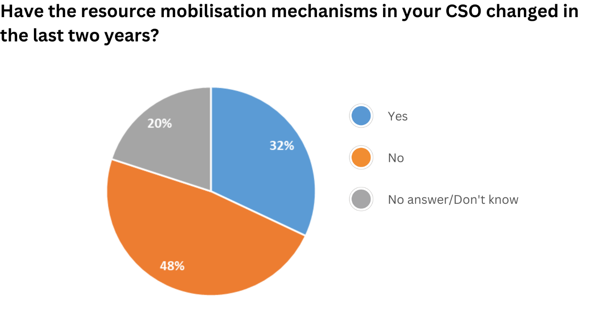
6.2. Main Sources of Funding
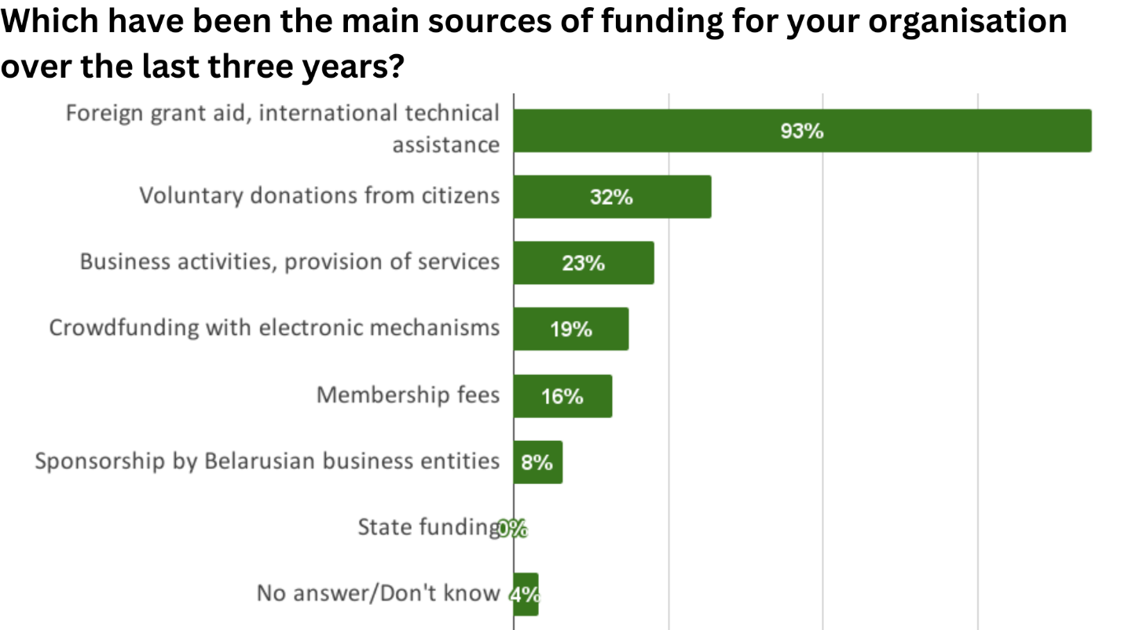
93% of the CSOs indicate that foreign funding, including foreign grant aid and/or international technical assistance, was the source of funding for them in the last three; 32% mentioned voluntary donations from citizens; 23% mentioned entrepreneurial activities and services provided, 19% mentioned crowdfunding using electronic mechanisms, 16% mentioned membership fees, and 8% mentioned sponsorship from Belarusian business entities.
Other sources of funding include support from other CSOs, as well as own contributions from their founders, team members, and leadership.
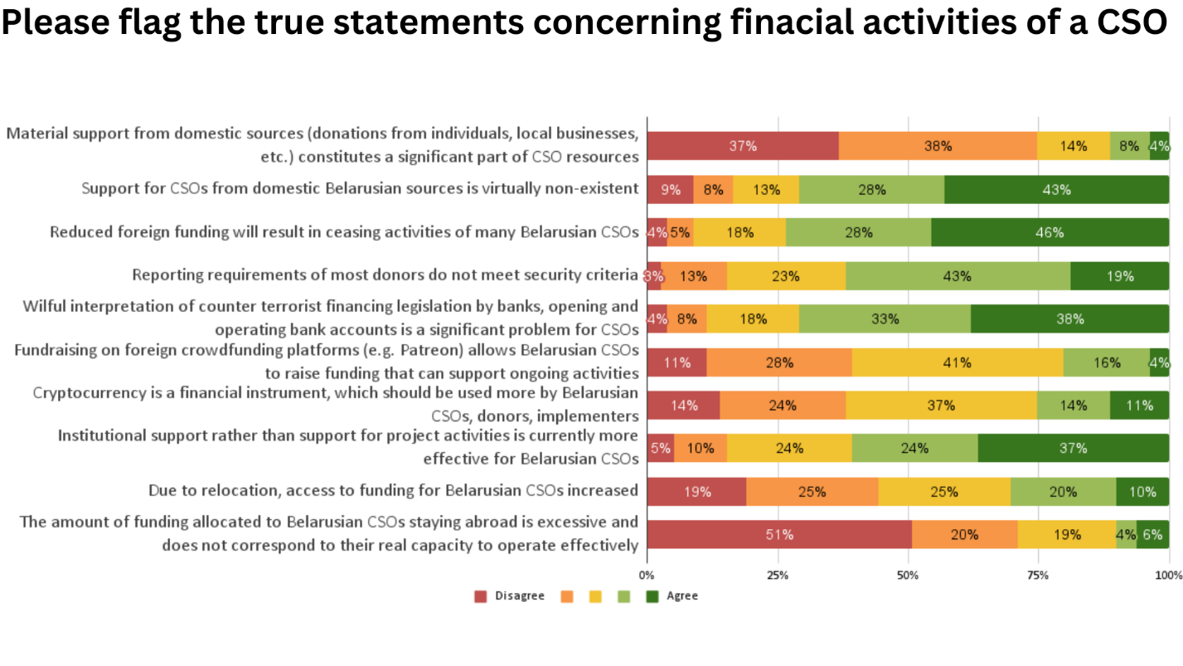
In the course of the survey, the CSOs were proposed to select the statements concerning financial activity which in their opinion are true. They were given a scale of 1 to 5, where 1 is "Disagree completely" and 5 is "Agree completely”.
Statement | 1. Disagree completely | 2. | 3. | 4. | 5. Agree completely
Material support from domestic sources (donations from individuals, local businesses, etc.) constitute a significant part of CSO resources | 37 % | 38 % | 14 % | 8 % | 4 %
Support for CSOs from domestic Belarusian sources is virtually non-existent | 9 % | 8 % | 13 % | 28 % | 43 %
Reduced foreign funding will result in ceasing activities of many Belarusian CSOs | 4 % | 5 % | 18 % | 28 % | 46 %
Reporting requirements of most donors do not meet security criteria | 3 % | 13 % | 23 % | 43 % | 19 %
Wilful interpretation of counter terrorist financing legislation by banks, opening and operating bank accounts is a significant problem for CSOs | 4 % | 8 % | 18 % | 33 % | 38 %
Fundraising on foreign crowdfunding platforms (e.g. Patreon) allows Belarusian CSOs to raise funding that can support ongoing activities | 11 % | 28 % | 41 % | 16 % | 4 %
Cryptocurrency is a financial instrument which should be used more by Belarusian CSOs, donors, implementers | 14 % | 24 % | 37 % | 14 % | 11%
Institutional support rather than support for project activities is currently more effective for Belarusian CSOs | 5 % | 10 % | 24 % | 24 % | 37 %
Due to relocation, access to funding for Belarusian CSOs increased | 19 % | 25 % | 25 % | 20 % | 10 %
The amount of funding allocated to Belarusian CSOs staying abroad is excessive and does not correspond to their real capacity to operate effectively | 51 % | 20 % | 19 % | 4 % | 6 %
6.3. Main Sources of Funding
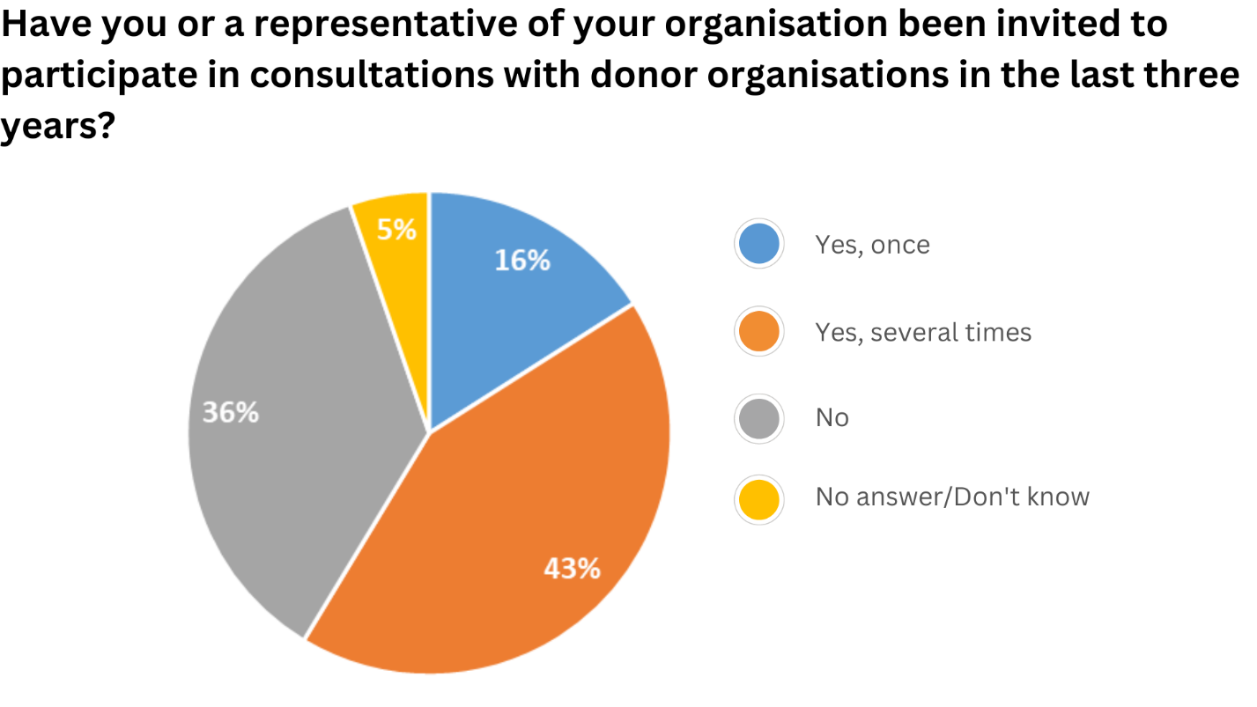
43% of the CSOs note that their organization's representatives was invited to participate in consultations with donor organizations a few times in the last three years, 36% note that they were not invited to participate in consultations with donor organizations, 16% were invited once, and 5% had no answer to this question.
7. Other Issues Relating to CSO Activities

7.1. Methods/Tools for CSO Activities
The CSOs were asked to select among the provided options the methods (tools) they use in their activities constantly, often, seldom, or not at all.
Methods | No use at all | Seldom | Often | Regularly | No answer/Don't know
Dissemination of information, including through the media, the Internet | 0 % | 15 % | 15 % | 71 % | 0 %
Education | 5 % | 9 % | 33 % | 52 % | 0 %
Participation in public, advisory, and expert councils, as well dialogue platforms | 8 % | 40 % | 31 % | 20 % | 1 %
Monitoring and evaluation of the situation and/or of the implementation of the authorities decisions | 21 % | 23 % | 27 % | 21 % | 8 %
Service provision, social entrepreneurship | 48 % | 32 % | 8 % | 7 % | 3 %
Preparation of shadow reports to international organizations | 35 % | 27 % | 13 % | 15 % | 7 %
Conducting studies | 17 % | 43 % | 29 % | 24 % | 0%
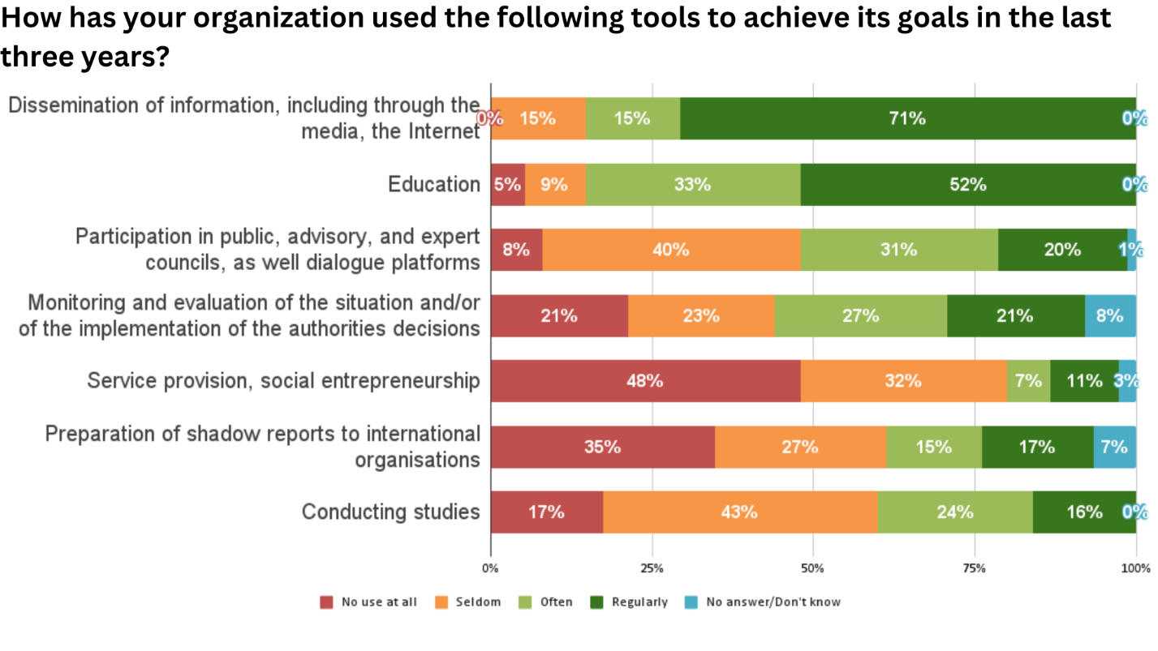
7.2. Assessment of Belarus`s Public Sector Activities
In the course of the survey, the CSOs were asked to rate the success in the activities of their organizations and of the public sector of Belarus over the past three years on a scale from 1 to 5, where 1 is ‘Total failure’ and 5 is ‘Total success’.
Entity to rate | 1.Total failure | 2. | 3. | 4. | 5. Total success
The CSO being surveyed | 0 % | 13 % | 45 % | 36 % | 5 %
Other Belarusian CSOs working in the same area | 5 % | 13 % | 47 % | 32 % | 3 %
New structures of the Belarusian political opposition abroad | 12 % | 31 % | 35 % | 23 % | 0 %
Belarusian human rights movement | 1 % | 5 % | 23 % | 55 % | 16 %
Civil society in Belarus as a whole | 4 % | 20 % | 40 % | 31 % | 5 %
